**Name**

Mark George

**Student Number**

S3886745

**Student Email**

s3886745@student.rmit.edu.au

**Age**

18

**Picture**



**Nationality and Culture**

Egyptian, more specifically, Coptic Orthodox.

**Ideal Job**

In the future, I would like to work as a Cyber Security Specialist

**Personality Test**

After completing the <http://www.16personalities.com/> personality test, I received the following results:

* 76% extraverted, 24% introverted
* 73% intuitive, 27% observant
* 21% thinking, 79% feeling
* 40% judging, 60% prospecting
* 40% assertive, 60% Turbulent

**Learning Style Test**

http://www.educationplanner.org/students/self-assessments/learning-styles-quiz.shtml?event=results&A=9&V=5&T=6Auditory: 45%

* Visual: 25%
* Tactile: 30%

I am an **Auditory** learner

**The Big Five Personality Test**

https://www.truity.com/personality-test/17315/test-results/31914363

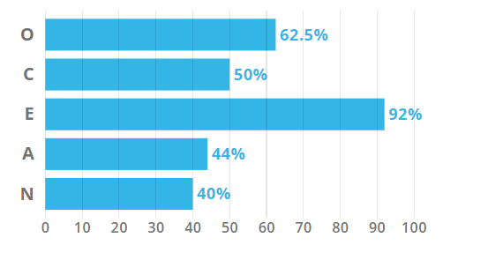

These results help me come to an analytical conclusion that I would be a great addition to a collaborative team. When forming a team, the results suggest that my role should be interaction based since I have a very high extraverted score, this may mean doing a lot of the talking whether that is through suggestions or helping others understand each other with my input.